I
P R E
L
Ingenjörsfirma
PRocess och Energi-
konsult Lundholm
(PRocess and Energy
Engineering Consultant
Lundholm)

IPREL  Norrskensbacken 11  S-146 46 TULLINGE  SWEDEN  tel 08-778 46 36  0705-64 65 18  www.iprel.se  BUSINESS FIELD: | 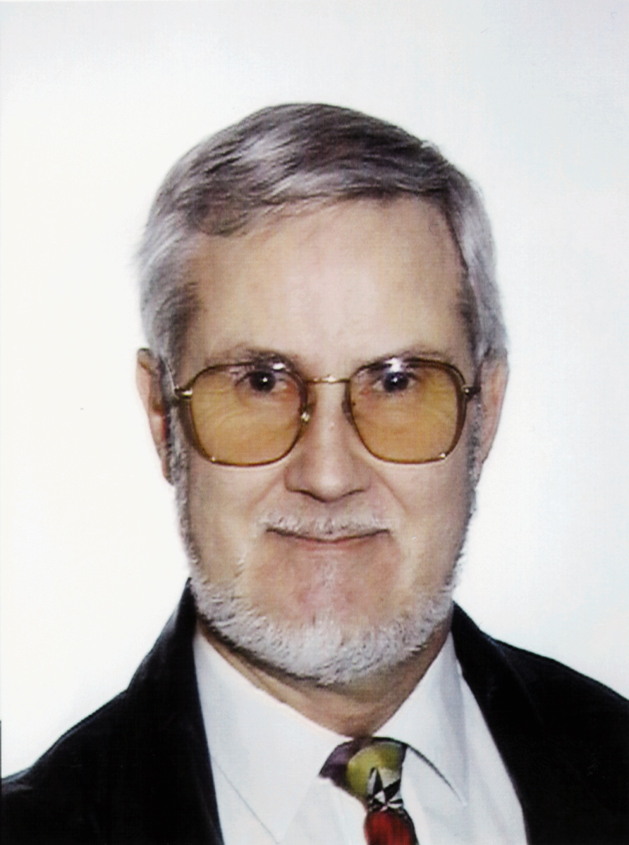

Investigations Energy Processing
Chemical Processing
Heat Recovery
Energy-technical Optimising
Technical Foundations for Budgeting
Layout Working

Calculations Investment Calculations
Strength Calculations
Pressure drop Calculations
Heat Technical Calculations

Design Process Piping
Foundations for mandatory Design Review
Co-ordination of different technical Systems
Drawings for hole making and steady Supports
Foundations for Offering and Procurement

Supervision Design supervision acc. to valid codes
Supervision at erection of equipment
Budget re-evaluation after finalised project

Quality Assurance Manual

Curriculum Vitae.

TECHNICAL BACKGROUND.
Born 31-03-1943, I graduated in 1963 with an upper secondary engineering course at Thorildsplans gymnasium in Stockholm. My special interest was machinery.
From 1964 (after military service) I was employed for 16 years at Ångpanneföreningen (Swedish Steamusers Association) in Stockholm. The first 5 years I was placed in the design office.
In 1969 I moved to the Environment supervision department. From this department I have most of my knowledge about Pulp processing, scrubber columns and combustion equipment for environmental polluting materials. My major commission in the environmental field, was ASSI Lövholmens Bruk, which covered the taking care of and burning of nasty smelling gases without heat value as primary air to oil-burners, and burning of dangerous gases in a "Volvo-furnace" that was constructed for this purpose. Furthermore a system was installed for separating and scrubbing of contaminated condense and reusing of the water in the different processes.
In 1974 I returned to the design department. My major commission was Holmens Bruk, Bravikens Pappersbruk, where I under supervision of the project leader performed layouts, Installation drawings, Process piping, Drawings for hole making and steady supports for support of process piping, cables and Service Systems. Furthermore I performed necessary calculations of strength and wrote programs for the procurement of piping and components, and had the contact with the authorities (SA) which had the responsibility to review and supervise that the work was erected in accordance with the rules. Construction supervision was also included in the commission.
In 1981 I took up an employment at "Vattenfall" (Swedish State Power Board) after been engaged as a consultant from ÅF for 17 months. At Vattenfall I performed the same kind of work as at ÅF. The major commission was ”Stenungsunds Kraftstation" (Stenungsund Power Station), where my knowledge was increased in about critical flows in steam and water piping and calculation of remaining life of high stressed piping. I also worked with oil storage in rock caverns in Stenungsund. I worked with Heat Pumps, with the BIOTURBO, and conventional coal combustion. During 9 months 1984-85 I was leased to ABB-STAL, department PTPV for design of oil cooling equipment and high-pressure-valves to VAX-turbines with design-data 160 bar, 530 ºC.
In 1985 I returned to ÅF, since the office where I was employed was to be closed down. My first commission at ÅF this time was for " Fagersta Stainless" where I got the task of connecting exhaust-gas-furnaces to the district heating system. In the central heating plant HEDEN 1, in Karlstad, I had the co-ordination responsibility between the house builder (J&W), and other contractors, as well as between contractors, to deliver foundation drawings for hole-making and steady supports in concrete, and to control that no collision occurred in between process piping, cable-ladders, service systems and ventilation piping.
In 1986 I was back in Vattenfall as a consultant from ÅF. This time I was engaged in "Ringhals avfallsprojekt". This was a project for taking care of low- and medium-radioactive sludge, de-watering of the substances and mixing with concrete, for future deposit in the underground store at Forsmark. The commission included projecting and writing of programs.
In 1983 I became engaged as an administrative project secretary for the TKK committe 12a and held that position until the publication of "NATURGASSYSTEMNORMER NGSN 1987" (Natural Gas System Norms >4 bar).
Since 01-11-1987 I have had a business of my own. After 1 month at Vattenfall with documentation for waterpower stations, I worked for ABB-STAL in Finspong for 9 months. My commission for ABB-STAL was connection of the steam turbine in Värtan to the PFBC combustor delivered by ABB Carbon in Västerås. The project covered designing and calculation of power- and movement caused stresses and similar tasks. ABB personnel supervised the commission.

As consultant at SA (Svensk Anläggningsprovning) in Stockholm I performed review of industrial constructions according to current norms and codes. Among the projects I can mention the ABB-PFBC in Värtan, although I was prohibited to review my own constructions on the turbine side, I could review the combustor Vessel with its contents. I also reviewed a number of LPG works.
In Fagersta I worked with several projects, for example, cooling of compressors, warming of salt-solutions, cooling of bate-solutions, comfort ventilation, transportation of grind-dust and ventilation of hydrogen from battery loading equipment.
During 1990 I was occupied with the installation of filterpresses to Calbe in eastern Germany. The commission included changes in the manufacturing drawings of the filterpresses as well as installation drawings with necessary calculations and programs. During the erection I was at hand on the site when necessary.
In 1991 I designed furnace-gas-pipes and vents for damp air to exhaust-gas condensation equipment for Linköping County Council Energy Board, with consideration of thermal forces, stresses and movements. I was sub-contractor to the deliverer of the condensation equipment (Fagersta Energetics).
In 1992 I straightened a filterpress in Ulricehamn, that had been twisted as a result of askew load. The working of the press was documented by use of strain gage, and the press was thoroughly fixed to prevent future damages as result from askew loads.
In 1992 I have designed furnace-gas-pipes for Karlstad County Council Energy Board in about the same way as for Linköping, and as sub-contractor to Fagersta Energetics.
In 1992 I finalised my first edition of Quality Manual in Swedish.
1992-09-01 to 1994-08-31 I have been working for the SwedEF group in Saudi Arabia. The project "SSSP" is a strategic storage project for refined oil products in rock caverns. My tasks in that project have been in the Product Department to check the documents from ABV Rock Group produced during Conceptual Design.
During that session I also performed two lectures for the SSSP personnel, namely " Vapour pressure, nature and consequences" and "Nomographic presentation of formulas, background and use in daily work".
1995 -96 I have been working on SAQ in Gothenburg with the same responsibilities as for SA in Stockholm 1988.
1998-1999 I have been working as subcontractor to KNIGHT Industry Technics at ABB Stal in Finspång with upgrading of material standards on spare part drawings of age for the Service department.
1999-2000 I have designed furnace-gas-pipes for Västerås County Council Energy Board in about the same way as previous described using AutoCAD 14. Ditto for Gärstad and Arvika.
2000-2001 I have been working for STEAMBOX AB designing electrical Steam Boilers.
2001 I have maid a layout for Zander & Ingeström concerning Boiler House to Uddeholm Tooling.
2001-2002 I have been working for Fagersta Energetics with installations for furnace gas condensing till Brista Kraftvärmeverk in Märsta.
2002-2003 I have re-designed the STEAMBOX electrical steam boilers to the PED-directive.
2004-2005 I have been employed as subcontractor to SwedPower, working with connections between Bloc 5 (Garbage incineration) and old heat-installations in Uppsala.
2005 I have completed the Steambox Steam-generators with basic information and established that they got an “Assembly Certificate” approval from DNV.
2006 I have supported Steambox technical and administrative at establishing the Factory Tests (FAT) and Site Installation Tests (SAT) for a delivery of Steam generators (280 + 480 kW) to BioPharma in Lund.
During my work I have made use of microcomputers, mostly for administration, but also for calculations and for CAD. In 1991 I bought my first complete CAD-station with AUTOCAD 10. This I have upgraded to AUTOCAD 12 and 14. At my clients I use AUTOCAD 2002.
During my work I have experienced both English and German as project-languages.

PERSONAL BACKGROUND.

NAME Björn Lundholm

BIRTHDAY March 31, 1943
AND PLACE Stockholm

NATIONALITY Swedish

LANGUAGES Swedish, English, German

EDUCATION Thorildsplans Technical Gymnasium
AND DATE 1960 - 1963

EMPLOYMENTS.

2004 - Ingenjörsfirma PRocess och Energikonsult Lundholm
Consultant, Self employed.

1995 - 2003 Ingenjörsfirma PRocess och Energikonsult Lundholm AB
Consultant, Self employed.

1994 - 1995 Ingenjörsfirma PRocess och Energikonsult Lundholm
Consultant, Self employed.

1992 - 1994 SwedEF
Senior Adviser.

1987 - 1992 Ingenjörsfirma PRocess och Energikonsult Lundholm
Consultant, Self employed.

1985 - 1987 ÅF Energikonsult AB, Stockholm
Heat technician, Project engineer.

1981 - 1985 Statens Vattenfallsverk
Heat-power technician, Calculation engineer,
Design engineer.

1975 - 1981 Ångpanneföreningen, Stockholm
Calculation engineer, Design engineer.

1970 - 1975 Ångpanneföreningen, Stockholm
Environmental Control Department.
Project engineer.

1964 - 1970 Ångpanneföreningen, Stockholm
Calculation engineer. Design engineer.

MAIN PROJECTS WITH REFERENCES.
Year Project Type of occupation Reference Address and
(name) telephone
-------------------------------------------------------------------------------------------------------------------------------------------------------------------------

2005 STEAMBOX AB Assembly approval of Stembox Nils Björkman Box 87
Steamboilers 125 22 ÄLVSJÖ
+46-8-7793910

2004-05 Uppsala Energi Connecting new incineration- Jonas Forsman Box 527
SwedPower plant to old equipment using Anders Eidensten 162 16 STOCKHOLM
AUTOCAD 2003. +46-8-7395000

2000-04 STEAMBOX AB Design of Electric Steamboilers Nils Björkman Box 87
125 22 ÄLVSJÖ
+46-8-7793910

2001 Zander & Ingeström Layout of Steam Boiler room Gunnar Hellström Box 502
for Uddeholm Tooling 169 29 SOLNA
+46-8-809000

1999-02 Fagersta Energetics Designing Channels Kjell Björling Axel Fornanders Väg
S-737 40 FAGERSTA
+46-223-45067

1998-99 ABB Stal Supervision and upgrading Håkan Jonhed S-61282 FINSPÅNG
of material standards +46-122-81000

1997-98 Hydralift ASA Design work. Offshore equipment Svein Stubstad 4604 KRISTIANSAND
using AUTOCAD 12 Janne Krohn NORGE
+47-380 49500

1997 Uppsala Energi AB Restoration of corroded fuel-filter Magnus Köhler Box 129
Design of transfer pipeline for Diesel oil 751 04 UPPSALA
+46-18-272700

1995-96 Svensk Anläggningsprovning Review of design according Kjell Vågfelt Gyllenkrooksgatan 10B
to current codes and norms Sven Rydén S-412 61 GÖTEBORG
+46-31-818500

1992-94 SSSP (Swedef) Saudi Strategic Storage Program Sunil R Bandopadhyay
Senior Adviser Göran Heimersson +966-1 477 2333

1992 Fagersta Energetics Designing Channels Lars Tiberg Fagersta Energetics
Axel Fornanders V@g
1991 Fagersta Energetics Designing Channels Lars Tiberg S-737 40 FAGERSTA
+46-223-45067

1990 NovaTek Design and instalation of Lars Delham NovaTek
Filterpresses Box 9081

S-151 09 SÖDERTÄLJE
+46-8-55010071

1989 Svensk Anläggningsprovning Control of Design according Christer Hjelmare Box 49306
to current norms C J Börjesson S-10028 STOCKHOLM

+46-8-6174000

FAMILY CIRCUMSTANCES.
I was married from 1974 to 1995 and have two children, now aged 32 and 24.
My previous wife is a psychiatric social worker.
Since 1987 when I started my business I have been -95% working in my employers office.

My interests besides my work, is reading, myths, ancient history, theater and chorus singing.

CIVIC AFFAIRS.
From 1972 to 1976 I was engaged in civic affairs, namely:
1972 - 1973 Lay Assessor.
1974 - 1976 Deputy of public Health and Environmental Supervision Committe.
1974 - 1976 Member of Assessment Board.
1974 - 1976 Chairman of local County Council.

I
P R E
L
Ingenjörsfirma
PRocess och Energi-
konsult Lundholm
(PRocess and Energy
Engineering Consultant
Lundholm)

Examples of Consulting Services.

1. Coordination.

1.1 Contacts with head contractors.
1.2 Design of layouts regarding:
- Process.
- Service systems (main paths for process piping, ventilation, Power and Control systems, Pressurised air, Fire and rinsing water, Internal heat systems).
- Construction matters.
1.3 Design of P&ID:s.
1.4 Design of "upper edge" drawings, as basic for the building entrepreneur, showing positioning of head components, loads, foundations, holes and fixed irons in loaded constructions
1.5 Responsibility for co-ordination and avoiding of collisions in between :Components, Process piping, Electrical cables and Service systems.

2. Design Work.

2.1 Installation drawings for service systems, excluding electricity and ventilation.
2.2 Offering specifications for service systems according to above comprising drawings and specifications.
2.3 Necessary technical calculations.

3. Erection control.

3.1 Partaking or executing in project meetings each week during the construction phase.
3.2 On Site erection control according to approved drawings.
3.3 Writing of minutes of the meeting.

4. Document handling.

4.1 Evaluation of vendors quality system.
4.2 Collection and approval of suppliers documents.
rem. Where mandatory control is prescribed, authorities shall approve those documents.
4.3 Delivering of complete documents after closing the project.

5. Finalizing works.

5.1 (Control of) Final revision of drawings.
5.2 (Control of) Operational Instructions.
5.3 (Control of) Maintenance Instructions.
5.4 Education of operation personnell regarding operation instructions.

I
P R E
L
Ingenjörsfirma
PRocess och Energi-
konsult Lundholm
(PRocess and Energy
Engineering Consultant
Lundholm)

Examples of commissions of energy analysis.

1. Mapping of the energy balance of the plant.
2a. Investigation of consequences from closing and re-circulation of certain systems.
2b. Investigation of possibilities to change temperature levels in between parts of the plant.
2c. Investigation of possibilities to change parts of the process in the plant.
2d. Investigation of possibility to change the type of primary energy.
3. Economic valuation regarding the measures according to above.
4. Quality control if the connected systems have the quality to be connected to a new or extended system.
5. Proposition of measures to be taken.
6. If the proposal implies the start of a project, there shall be presented a PM with foundations for a decision by the client executive board. The PM shall contain:
- Dimensioning background.
- Lists of quantities and materials.
- Budget.
- Preliminary time schedule.

I
P R E
L
Ingenjörsfirma
PRocess och Energi-
konsult Lundholm
(PRocess and Energy
Engineering Consultant
Lundholm)

Examples of commissions in Project leading position.

1 Contacts with suppliers and contractors for confirmation of commissions, limits of delivery, time schedule, responsibility, obligations of reporting etc.
2 Establishing of combined installation drawings in sufficient amount for the control of that no encounterance will occur in between components, process piping, service systems etc.
3 Control of security systems (fire water, fire extinguishers, fire ventilation, excavation routes, noise protection etc.) in cooperation with local safety supervisor and communal authorities.
4 Control of transportation routes and possibilities to serve all components for maintenance or exchange.
5 Establishing of "upper edge drawings" as support for the building contractors drawings regarding location of main components, loads, holes in loaded constructions and location of fixed supports in the casting.
6 Control of embankments and the proper inclination of floors against drained low point.
7 Control and clarification of instrumentation and interlocks in the form of interlocking charts.
8 Establishing of cleaning, tests and test operation programs.
9 Establishing plan for recurrent project meetings.
10 Establishing area planning for each contractor according to their demand of space for material and personnel during the construction phases on the Site.
11 Planning of internal transports and erection of heavy components.
12 Chairmanship and writing of the minutes of the meeting at recurrent project meeting.
13 Updating of time schedules.
14 Establishing the responsibility for occurring penalties.
15 Control and approval of suppliers and contractors quality documents regarding material and performance.
16 Control and approval of suppliers and contractors "as built" drawings according to actual final delivery.

